Zack Brittain

bri14141668@student.citybathcol.ac.uk

Abstract

In the follow report the author defines and explores the projects overview including the objectives, constraints and implications, required resources and risks associated with its development. Furthermore, the author offers an overview of the project plan along with any relevant Gantt charts which will be used in its development.

Development Project lP30483

*Research Question: Can AI improve the day-to-day lives of humans?*

Table of Contents

2 Introduction 2

3 Project Overview 2

3.1 Project Terms 2

3.2 Project Introduction 2

3.3 Identified Issues 3

3.4 Proposed Solution 4

3.5 Project Stakeholders 4

3.5.1 Internal 4

3.5.2 External 4

3.6 Project Research 5

4 Project Objectives 5

5 Technical Constraints 6

6 Implications 6

6.1 Ethical 6

6.2 Legal 6

6.3 Professional 7

7 Required Resources 7

7.1 Software 7

7.2 Hardware 8

8 Associated Risks 8

9 Project Plan 9

9.1 Overview 9

9.2 Milestones 9

9.3 Change Management 9

9.3.1 Change Control 10

9.4 Gantt Chart 10

10 References 12

11 Appendix 14

11.1 Appendices A – Project Sponsor Letter 14

11.2 Appendices B – Gantt Chart 15

11.3 Appendices C – Change Request Form 18

# Introduction

The following document will explore the plan for the projects development, of which is trying to answer the follow question:

*Can AI improve the day-to-day lives of humans?*

To answer this question, a client has been sourced who requires a chatbot that interacts with the elderly in an attempt to reduce the level of loneliness they experience on a daily basis. Users of the chatbot should be able to converse in a written or verbal format where the chatbot should then respond in a similar manner. This allows for maximum reach to the elderly who may not be comfortable with the use of, or are unable to use a keyboard.

According to a study conducted by

# Project Overview

The following section offers a brief overview of the terms used, the project itself, the identified issues with solutions, and any project stakeholders.

## Project Terms

In the table below, the technical terms and acronyms of which are to be used throughout the remainder of this report are identified and defined.

|  |  |  |
| --- | --- | --- |
| **Acronym or Term** | **Meaning** | **Definition** |
| **AI** | Artificial Intelligence | Any intelligence that replicates all of, or a partition of human intelligence. (Rouse, 2018) |
| **Chatbot** | N/A | A AI program that holds the capability to artificially simulate a conversation towards another human. (Techopedia, 2019) |
| **DL** | Deep Learning | DL is a subset of ML that describes a AI which learns without supervision from unstructured/unlabelled data. (Frankenfield, 2018) |
| **ML** | Machine Learning | ML is an expansive subset of AI which is used to describe a AI with the ability to access and learn from data independent of a human. (Machine Learning, 2019) |

Table - Terms and acronyms to be used throughout the report

## Project Introduction

The selected top of research is that of AI (Artificial Intelligence) and the effect that it will have on the individuals within our modern day social. Some argue that the development and implementation of AI could lead to potentially devastating scenarios. One example of this is when billionaire and entrepreneur Elon Musk once warned that AI could be humanities “*biggest existential threat*”. (Gibbs, 2014)

With this said, the potential for a positive impact of AI on our modern society could also be overwhelmingly positive. Examples of positive AI developments are currently being made within industries such as healthcare. In 2018 AI research company *DeepMind* made a medical breakthrough in how proteins fold themselves within a three dimensional space. The AI suitably named *AlphaFold* successfully predicted how 25 of 43 proteins would fold within the brain. (Mok, 2018) This breakthrough could lead to treatments in conditions such as Parkinson’s, diabetes and Alzheimer’s disease. (Sample, 2018) An estimated 7 to 10 million people are effected by Parkinson’s disease worldwide (Parkinson’s Disease Statistics, 2019), so any developments made towards new treatments would be welcomed by many.

## Identified Issues

AI is become increasingly ubiquitous across a variety of existing industries of which could have a direct impact upon our lives. (Grob, 2017) AI Chatbot’s are being used within customer service interactions, such as those held on platforms such as Amazon. When an Amazon customer requests a live chat, a AI chatbot is initially used to determine the category of customer issue or query and what the best solution for it.

This is an alternative to the more classical live chat model where a customer would have to wait for a customer service agent (human) to become available, before the employee then has to manually address the issue. In the case of Amazon’s live chat service this is no longer applicable, as the AI may be able to automatically sort returns, refunds or delivery issues without the input from a paid human representative.

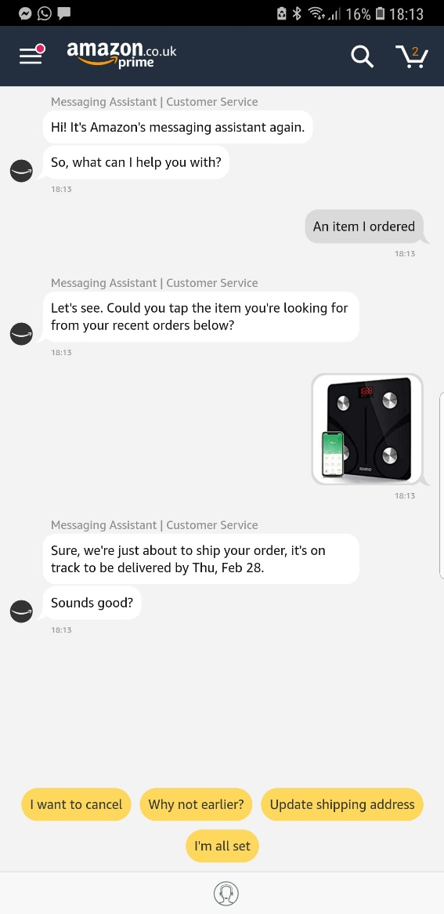

Figure - Screenshot of an example conversation between Amazons AI chatbot and a customer

Another issue is that related to the number of elderly people experiencing loneliness in the UK. According to studies conducted by charity AgeUK, loneliness can be as detrimental to a person’s health as much as 15 cigarettes per day. It is said that 3.6 million elderly people live alone in the UK, of which 2 million are above the age of 75. (AgeUK, 2017) Several factors can influence ones level of loneliness which include the following:

* Lack of social interaction
* Poor or reduced health
* Genetic factors

## Proposed Solution

To answer the question of whether AI can positively benefit the lives of humans, a AI chatbot that communicates with the elderly will be developed to determine if AI can be used to provide artificial conversations for the elderly suffering with loneliness. Combining and developing existing chatbot technologies to apply to providing artificial human conversation to the elderly would not only explore the posed research question, but also provide a way for those who are not always able to socialise do so in their own time and in the comfort of their own homes.

The user’s feedback can be asked for twice per interaction with one prompt before with the seconds after. This is to be used as qualitative data to determine if the impact of the chatbot is as intended and if it can indeed improve the day-to-day lives of a specific age set of humans.

## Project Stakeholders

Any organization or project has stakeholders, regardless of its given structure or size. There are two categories of stakeholders within the project which can be described as *internal* and *external*. In the figure below, all stakeholders are identified within their respective category.

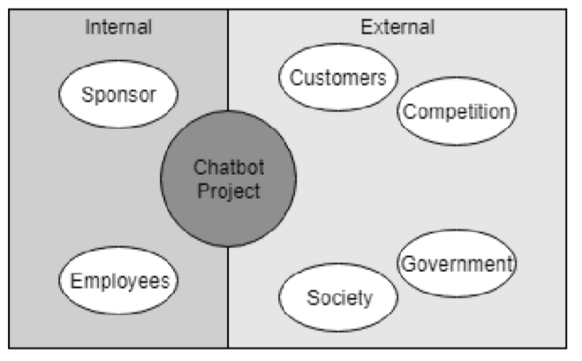

Figure - Internal and External Project Stakeholders

### Internal

An internal stakeholder is a party of individual whom are part of the organization or project in question. These individuals or parties serve or work for given the organization. Examples of internal stakeholders could include company employees, sponsors or investors. (Shurbhi, 2015)

The identified internal stakeholders for the project consist of the project sponsor and any applicable project employee(s). The project employee consists of myself whom will be undertaking and developmental and project management tasks. The project sponsor has defined the requirements and will remain to be a large part of the project throughout its development.

### External

An external stakeholder describes a party of individual whom are not directly part of an organization or project. External stakeholders do not serve or work for the given organization. Examples of external stakeholders could include governments or society.

In the case of this project four external stakeholders have been identified, beginning with the customer (end user). In the case of the chatbot there will be no direct financial cost to the end user, however this does not mean they do not impact the project. The demand from customers for the completed chatbot is a large influencing factor over the overall reach of the chatbot, thus dictating the amount of research possible from the project.

The second identified external stakeholder is alternative products from competition. There are indeed a range of artificial chatbot’s available at no cost online such as *Cleverbot* or *Mitsuku*, however these are influenced by a range of individuals and have not been aimed at such target audiences as the elderly. (Carpenter, 2019) (Worswick, 2019)

The government is another external stakeholder as they are the organization held responsible for changing laws and implementing new acts. For example, the DPA (Data Protection Act) was first introduced in 1998, where it remained unchanged for 20 years until 2018 when the GDPR (General Data Protection Act) was introduced, of which further increased security requirements for storing customer data. (Practical Law, 2019) Businesses and organizations then had to adjust their practices to remain within the newly adjusted law at their own cost and risk.

The final and arguably most impactful stakeholder is that of society and the ethical views they hold on the elderly conversing with a chatbot. Society will dictate the level of adoption for this new and untested technology in use with the elderly, so it’s purpose must be clearly defined, and its integration must be simple.

## Project Research

Over the course of the planning, development and integration of the project, data will be frequently gathered, reviewed and logged. This will all be planned and demonstrated within the completed project Gantt chart, which indicates periods of data gathering and analysis. Obtaining data will commence in a number of ways, including qualitative data from both wide public surveys and loneliness level feedback within the application. Additional data will be obtained from test plans and research as the project progresses.

# Project Objectives

Below are six objectives that are all to be met by the end of the agreed project date. These objectives have also been agreed upon with the clients permission. Proof of this can be found under appendices A below:

1. Determine whether a chatbot can be used to artificially simulate the communication towards another human being, answering the question: *Can be used to improve the day-to-day lives of humans?*

2. Deliver a functioning chatbot to the selected project sponsor within the agreed upon time period and achieving all agreed requirements.

3. Continuously consider all six identified project stakeholders and the impact that they may have on the project, or the impact the project may have on them.

4. Maintain pre-determined regular communication methods with the client which will consist of live video stream meetings and emails.

5. Consider and meticulously follow any current laws of ethical constraints that may affect the development or integration of the project.

6. Diligently ensure that all acquired data is securely stored and protected in a way that is both ethical and legal, whilst ensuring the purpose for data collection is clear to the subject.

# Technical Constraints

To ensure that a project's scope is fully gauged and understood, the technical aspects that may constrict the project must first be identified. Once these elements have been identified their potential impact on the project may then be gauged, allowing for a solution to be planned for before an issue occurs. Below are all identified technical constraints that may affect the project over its lifecycle.

The first element to consider would that that of the constraint with time. The time frame discussed and decided with the client totals at 10 weeks, meaning all research, planning, development and integration will need to be completed within these limited weeks.

The amount of designated time to the project may need to be increased in the case that a change requested is submitted that requires this. In this event, the change management control process will be closely followed which includes an option to increase the time frame and adjust the project plan accordingly.

# Implications

Three categories of varying issues have been identified of which compose of ethical, legal and professional implications. These identified issues can dictate a number of things, including how ubiquitous the chatbot can be, and the way in which data is handled and stored. Below are these three categories with their subsequent implications.

## Ethical

The main identified ethical implication is with that of whether the communication between an elderly person and a virtual chat bot is an ethical act to encourage. Should an lonely older person be subject to the potential abuse that heavily influenced chatbots can learn? Given that the relevant target audience is initially to be quite small, there is little risk of outside influence as there is with online chatbot’s. For example, Microsoft’s ‘Tay AI’ who was soon publishing racist and sexist comments after Twitter users exploited its self-learning algorithm by teaching it offensive slurs. (Vincent, 2016)

In addition to this, the way in which gathered information is handled is not only legally enforceable, but is also involved ethically. It is generally viewed as a personal right to have control over one’s data and how it is used and stored. (The University of Edinburgh, 2017) To ensure that any requirements in regards to ethicality are met when both collecting and handling data, only the most essential information will be gathered from those who choose to participate in testing, feedback or surveys.

For example, the names of individuals taking part in any surveys have no purpose for data analysis, meaning there is no need to ask or record for it. In contrast the age of each participant would be more applicable to the research project, and thus is required data.

Furthermore, the purpose for the collection of each piece of data must be clearly defined to all participants. For example, if a participant is asked to select an age bracket for a survey, then the participant should be made aware in what that data will be used for. After all, it is their own personal opinions (data) that is to be used in the project.

## Legal

Any organization or company that handles customer data must comply with the principles set out in the General Data Protection Act of 2018, which outlines several elements that must be followed in order to protect the given data. (Gov.uk, 2018) The six main principles of the GDPR (General Data Protection Regulations) compose of:

1. Lawful, transparent and – The processing of data must be handled in a specific way as described in the GDPR and the subject must be made fully aware of how their data will be used.
2. Defined purpose – According to the GDPR any data that is collected from a subject must be “adequate, relevant and limited to what is necessary in the relation to the purposes for which they are processed”. (Gov.uk, 2018)
3. Minimal data – Only the minimum required data should be taken from a subject and should be relevant to its use.
4. Accurate – All data records should be accurate and as up to data as possible.
5. Timescale – Data should only be held and stored for no longer than absolutely necessary.
6. Integral – According to the GDPR any data must be handled “in a manner appropriate security of the personal data including protection against unlawful processing or accidental loss, destruction or damage”. (Farrell, 2017)

Additional laws such as those outlined in the *Copyright, Designs and Patents Act of 1988* should also be considered in addition to data protection. In the act types of protected work are outlined (such as song lyrics, photography, video footage etc) of which provide the creators to protect their own work. (The UK Copyright Service, 2000) Using such protected works could lead to legal repercussions.

## Professional

The amount of agreed time is one of the biggest dictations in the management and handling of the project timescales. To ensure that the project is delivered by the agreed deadline (presuming that it is not extended due to a change request) one must meticulously follow the developed project plan, as time has been carefully and sensibly divided over a number of weeks. Following this plan will ensure that all objectives are met whilst delivering the chatbot within the agreed period.

Another concern relates to that of the current level of knowledge in the development of self-learning artificial intelligence. A given amount of time has been designated for education within the projects plan to ensure that any required knowledge is understood before either the design or development for the project begin. This includes research into SEQ2SEQ and Python, which are hugely responsible for the project code.

# Required Resources

Throughout the development of the project several resources are required to successfully complete the AI and all related assets. To ensure that all resources are fully planned for it is important to explore these aspects in greater detail before the project takes place.

## Software

There are numerous categories of assets and code that will be required for the successful design and completion of the project. Developing a self-learning chatbot requires a surprisingly large amount of installed software.

The project will be developed on Windows 10 (64-bit) for optimum compatibility with any software that requires installation (the hardware specification requirements for this machine can be found in the section below). The software that will be installed for the project consists of the following:

* Microsoft Office Suite – To view and edit the projects Gantt chart and access the change management control excel document.
* Python (complier download) – The primary language for the AI will be Python due to its ease of use in the development of chatbot’s and AI in general.
* Photoshop – To design and produce any required assets such as buttons or background artwork.
* Tensorflow resources – *TensorFlow* is an open sourced framework specifically designed for machine learning and AI. (TensorFlow, 2019)

## Hardware

The amount of required hardware for the entirety of the project is surprisingly limited. Other than a windows based computer with adequate specifications, there isn’t any additional hardware required. To run all of the required software the project, the given computer must have at minimum the following specifications:

● i5 Quad Core CPU (Central Processing Unit) - Allows for adequate processing power to run any required software.

● 8GB RAM (Random Access Memory) - Enough to allow for multiple programs to run at once, making development more efficient.

● 20GB storage - Enough room to install required software and for storage of any required assets. This will require encryption to ensure that all data is safely secured whilst keeping in line with Data Protection principles.

Fortunately, a computer that exceeds these minimum specifications is available for the project, and will be sourced from myself. The computer offers an i7 CPU paired with 32GB of RAM and plenty of solid state storage, making it perfect for the project. The storage of any project related data will be safely stored on a separate and encrypted partition. Any required software will be installed onto this computer, and any developments will also be made on this computer.

# Associated Risks

*what the risk is, why it’s a risk, how the risk will be approached*

One large associated risk with the project is that with the limit of time. A fully functional and usable chatbot must be delivered by the end of the given time frame, as agreed with the project sponsor. In the case of this chatbot project, a time frame of 10 weeks has been allocated by the project sponsor. In order to ensure that the project is delivered within the given timeframe, a Gantt chart must be closely followed to ensure that the amount of time provided to each task is accurate and what is required to meet the requirements. For example, the

In addition to time constraints, my own ability and confidence in developing an artificial intelligence will also dictate the project’s success. Before development starts, a thorough understanding of deep learning principles is required to ensure that the project will be delivered with adequate quality and within budget and time. Adequate time will be allocated for education in the subjects of Python and SEQ2SEQ within the project Gantt chart.

# Project Plan

The project will adopt the *agile* software development methodology throughout its planning. The agile methodology has been chosen over alternatives due to the large amount of flexibility it offers. Alternatives such as the waterfall methodology are more applicable to the manufacture of physical goods opposed to AI development due to its linear and less forgiving approach. (Lucidchart Content Team, 2017)

## Overview

There are three main stages in the design and delivery of an AI chatbot. The first stage is the planning in design of the AI itself, and gaining an understanding for how the chatbot will work. The second step is the actual development of the AI, completing any required code, design and user interfaces. The third and final stage is the training stage which will mostly consist of conversing with the chatbot in a manner that is applicable to the elderly. The training stage will likely be the most time consuming element as the bot will have no prior understanding of how to hold a realistic conversation. Hours of conversation must be had with the bot so it can learn how to converse in a realistic, appropriate and consistent manor.

There are more intermediary steps involved in the projects development which will be explored and identified within the projects Gantt chart. Additionally, all stages can be found in their chronological order below:

1. Gathering of requirements

2. AI design

3. AI deep learning training

## Milestones

In addition to meticulously following the developed project Gantt chart several milestones have identified in order to easily gauge one’s progress throughout the planning and development of the project.

1. Develop a working chatbot –
2. Teach the developed chatbot

## Change Management

To ensure that any changes put forward by the project sponsor or other stakeholders are adequately scrutinised and explored, a change management process can be used to add structure. (APM, 2019) For example, if the sponsor were to decide that they would like the chatbot to be available on another platform such as Mac, then the requirements and potential impact for the change can first be identified before deciding if its integration is feasible. Having a pre-determined consistent process for exploring any proposed changes ensures that each change is equally scrutinised.



Figure - Proposed process for managing potential changes

In the figure above, a basic overview for the planned path for change management is outlined in a diagram. The contents for each step are explained in more detail below:

|  |  |  |
| --- | --- | --- |
| # | Step Title | Description |
| **1** | Change Requested | The project sponsor would fill, sign/date and submit a request change form in digital format via email. This allows a copy of each change request to be easily logged and stored for potential future reference. |
| **2** | Assess | The change itself and any associated risks or legal/ethical implications must be explored and identified. Additionally, any requirements such as resources or time should also be examined and identified to the project sponsor either via email or meeting. |
| **3** | Prepare | If the project sponsor is happy with the any resource requirements (if applicable), and there are no major legal or ethical implications, then preparation should begin. This includes obtaining any identified requirements and assets. |
| **4** | Plan | The project plan should be adjusted in order to meet any agreed changes, whilst remaining within any agreed budgets or timescales. |
| **5** | Implement | Once the change has been assessed, prepared and planned for then its implementation can commence including any required asset design or code development. |

Table - Change management process explained

### Change Control

As defined above, all change requests must be sent via email and in a PDF format so that the documents can be digitally and securely saved. In addition to this, each change request will be assigned a version number which can be subsequently incrementally increased as the change is adjusted and discussed. For example, the first change submitted (change version v1.0) by the sponsor were to breach the data protection act, then this could be echoed to the sponsor before assessing their secondary and reviewed change request, which would subsequently be version v1.1.

The version number, dates, title and desired outcome for each change request will be logged within an excel spreadsheet. This will allow for an efficient way to log and view past changes, before referring to their respective PDF change request document. The example table below demonstrates what contents the excel spreadsheet will hold.



Table - Example change request entry within the prepared change log excel document

## Gantt Chart

A Gantt chart is a tool commonly used within project management and allows a visual solution to display tasks across a numbered timescale. As each task is visually represented it is easy to allocate resources to tasks whilst planning. (Gantt.com, 2019) In this case of this project, a Gantt chart has been developed to plan the project in its full length, ensuring all required tasks and resources are planned for. The developed Gantt chart for this project can be found under *appendices B* in its full below.

# References

AgeUK. (2017). *Loneliness*. Retrieved 02 15, 2019, from AgeUK.org.uk: https://www.ageuk.org.uk/information-advice/health-wellbeing/loneliness/

APM. (2019). *Change Management*. Retrieved 02 13, 2019, from Association for Project Management: https://www.apm.org.uk/body-of-knowledge/delivery/scope-management/change-management/

Carpenter, R. (2019). *Cleverbot*. Retrieved 02 14, 2019, from Cleverbot: https://www.cleverbot.com/

Farrell, S. (2017, 04 27). *The 6 Principles of GDPR*. Retrieved 02 15, 2019, from M Three Consulting: https://www.mthreeconsulting.com/blog/2017/04/the-6-privacy-principles-of-gdpr

Frankenfield, J. (2018, 03 09). *Deep Learning*. Retrieved 02 13, 2019, from Investopedia: https://www.investopedia.com/terms/d/deep-learning.asp

Gantt.com. (2019). *What is a Gantt Chart*. Retrieved 02 11, 2019, from Gantt.com: https://www.gantt.com/

Gibbs, S. (2014, 10 27). *Elon Musk: artificial intelligence is our biggest existential threat*. Retrieved 02 11, 2019, from The Guardian: https://www.washingtonpost.com/news/innovations/wp/2014/10/24/elon-musk-withartificial-intelligence-we-are-summoning-thedemon/?noredirect=on&utm_term=.bf34b98da760

Gov.uk. (2018). *Data Protection Act 2018*. Retrieved 2 11, 2019, from Gov Legislation: http://www.legislation.gov.uk/ukpga/2018/12/contents/enacted

Grob, M. (2017, 08 16). *We are making on-device AI ubiquitous*. Retrieved 02 11, 2019, from Qualcomm: https://www.qualcomm.com/news/onq/2017/08/16/we-are-making-device-ai-ubiquitous?cmpid=oofyus181544

Lucidchart Content Team. (2017, 11 02). *Lucidchart*. Retrieved 02 11, 2018, from The Pros and Cons of Waterfall Methodology: https://www.lucidchart.com/blog/pros-and-cons-of-waterfall-methodology Lucidchart Content Team

*Machine Learning*. (2019). Retrieved 02 13, 2019, from SAS Institution: https://www.expertsystem.com/machine-learning-definition/

Mok, K. (2018, 12 13). *DeepMind AI Makes Breakthrough with ‘Protein Folding Problem’*. Retrieved 02 11, 2019, from The New Stack: https://thenewstack.io/deepmind-ai-makes-breakthrough-with-protein-folding-problem/

*Parkinson’s Disease Statistics*. (2019). Retrieved 02 11, 2019, from Parkinson's News Today: https://parkinsonsnewstoday.com/parkinsons-disease-statistics/

Practical Law. (2019). *Comparisons: DPA 1998 v GDPR and DPA 2018*. Retrieved 02 14, 2019, from Thomson Reuters - Practical Law: https://uk.practicallaw.thomsonreuters.com/w-011-6935?transitionType=Default&contextData=(sc.Default)&firstPage=true&comp=pluk&bhcp=1

Rouse, M. (2018, 08). *AI (artificial intelligence)*. Retrieved 02 13, 2019, from TechTarget: https://searchenterpriseai.techtarget.com/definition/AI-Artificial-Intelligence

Sample, I. (2018, 12 02). *Google's DeepMind predicts 3D shapes of proteins*. Retrieved 02 11, 2019, from The Guardian: https://www.theguardian.com/science/2018/dec/02/google-deepminds-ai-program-alphafold-predicts-3d-shapes-of-proteins

Shurbhi, S. (2015, 08 31). *Difference Between Internal and External Stakeholders*. Retrieved 02 13, 2019, from Key Differences: https://keydifferences.com/difference-between-internal-and-external-stakeholders.html

Techopedia. (2019). *Chatbot*. Retrieved 02 13, 2019, from Techopedia: https://www.techopedia.com/definition/16366/chatterbot

TensorFlow. (2019). *TensorFlow*. Retrieved 02 15, 2019, from TensorFlow: https://www.tensorflow.org/

The UK Copyright Service. (2000, 04). *Fact sheet P-01: UK Copyright Law*. Retrieved 02 11, 2019, from UK Copyright Service: https://www.copyrightservice.co.uk/copyright/p01_uk_copyright_law

The University of Edinburgh. (2017). *Research ethics and data protection*. Retrieved 02 11, 2019, from Chem.ed.ac.uk: http://www.chem.ed.ac.uk/sites/default/files/research/research-ethics-data-protection.pdf

Vincent, J. (2016, 03 24). *Twitter taught Microsoft’s AI chatbot to be a racist asshole in less than a day*. Retrieved 02 15, 2019, from The Verge: https://www.theverge.com/2016/3/24/11297050/tay-microsoft-chatbot-racist

Worswick, S. (2019). *Meet Mitsuku*. Retrieved 02 14, 2019, from Pandorabots: https://www.pandorabots.com/mitsuku/

# Appendix

## Appendices A – Project Sponsor Letter

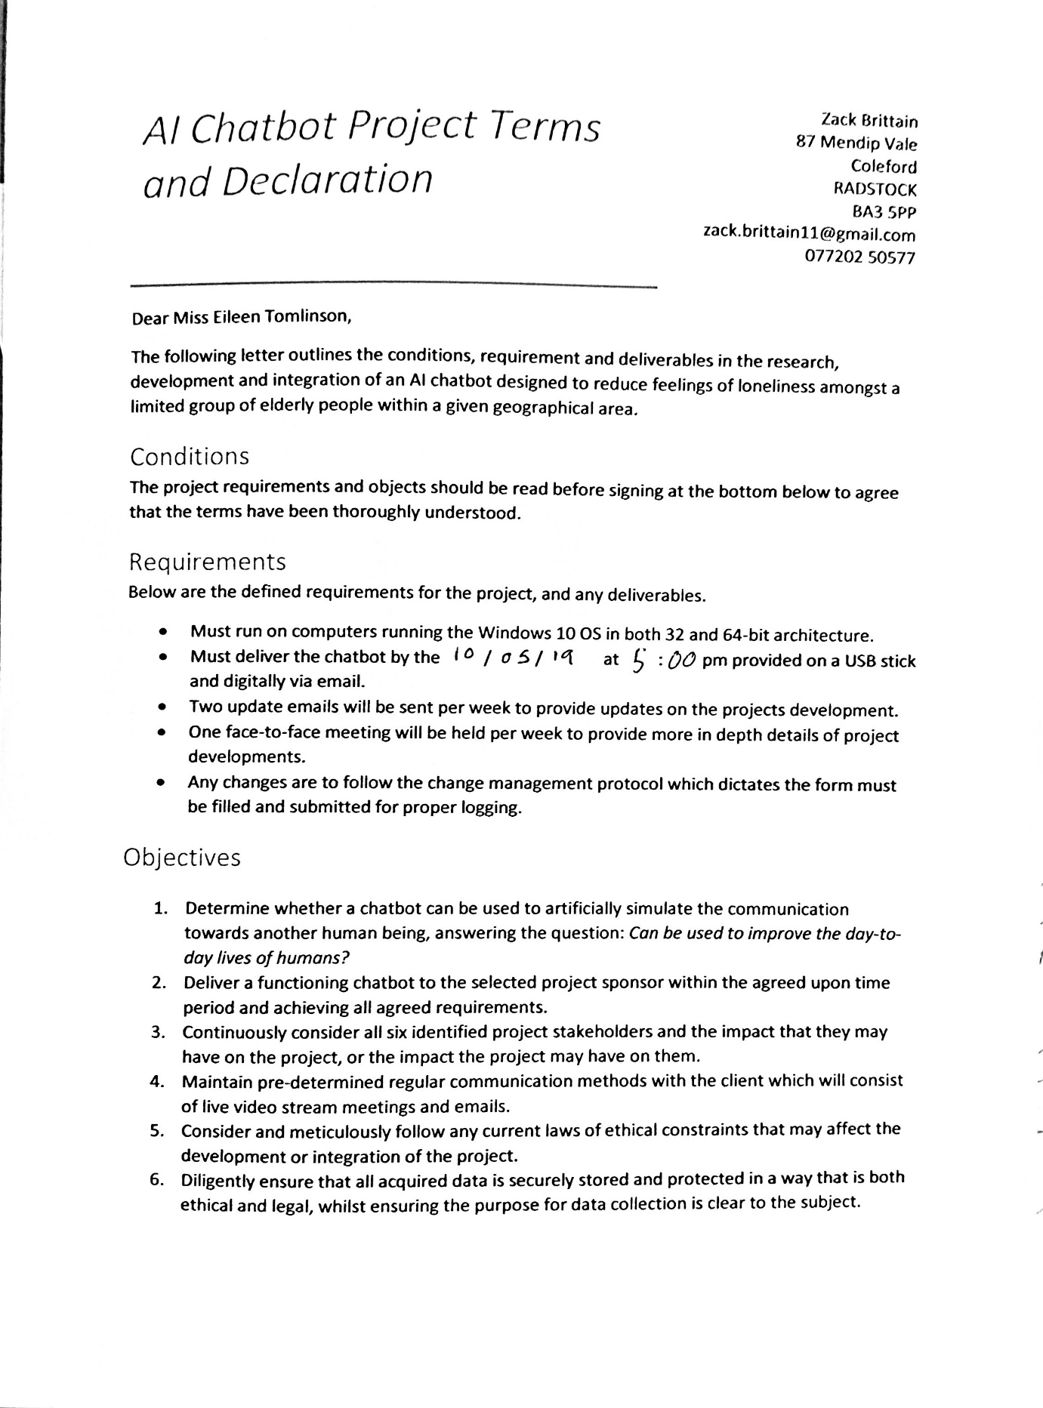

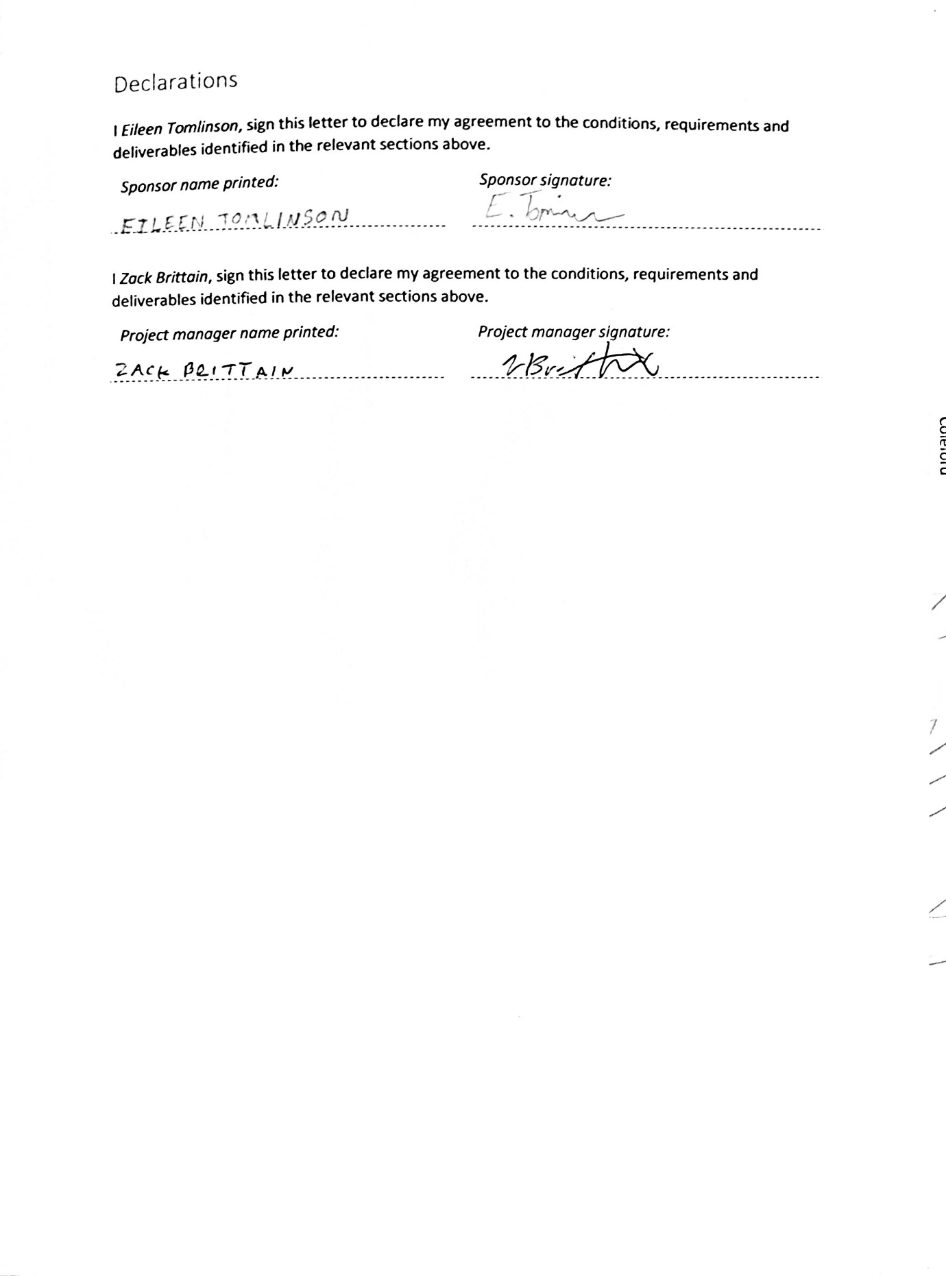

## Appendices B – Gantt Chart

The completed Gantt chart file can be found within the same folder this report is contained within. The chart was developed in Microsoft Projects, so it is recommended to use the same for viewing.

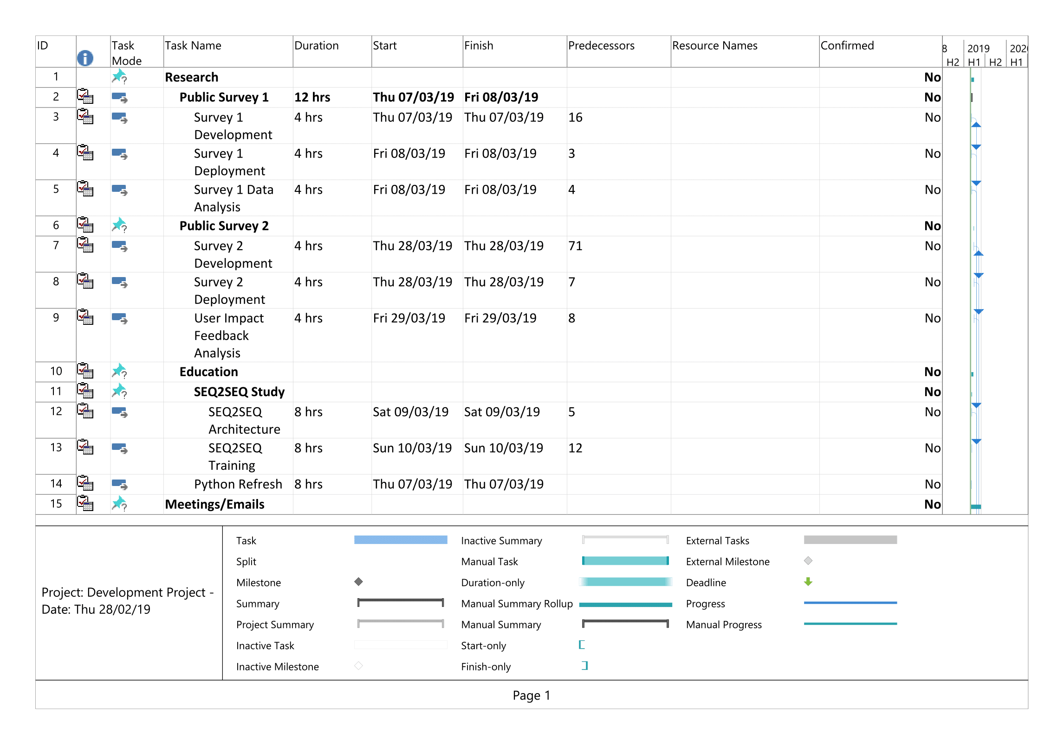

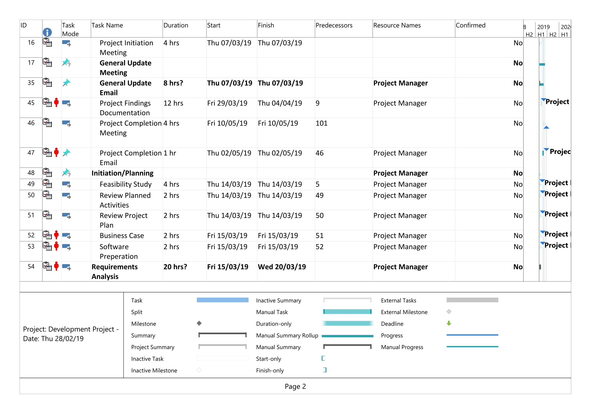

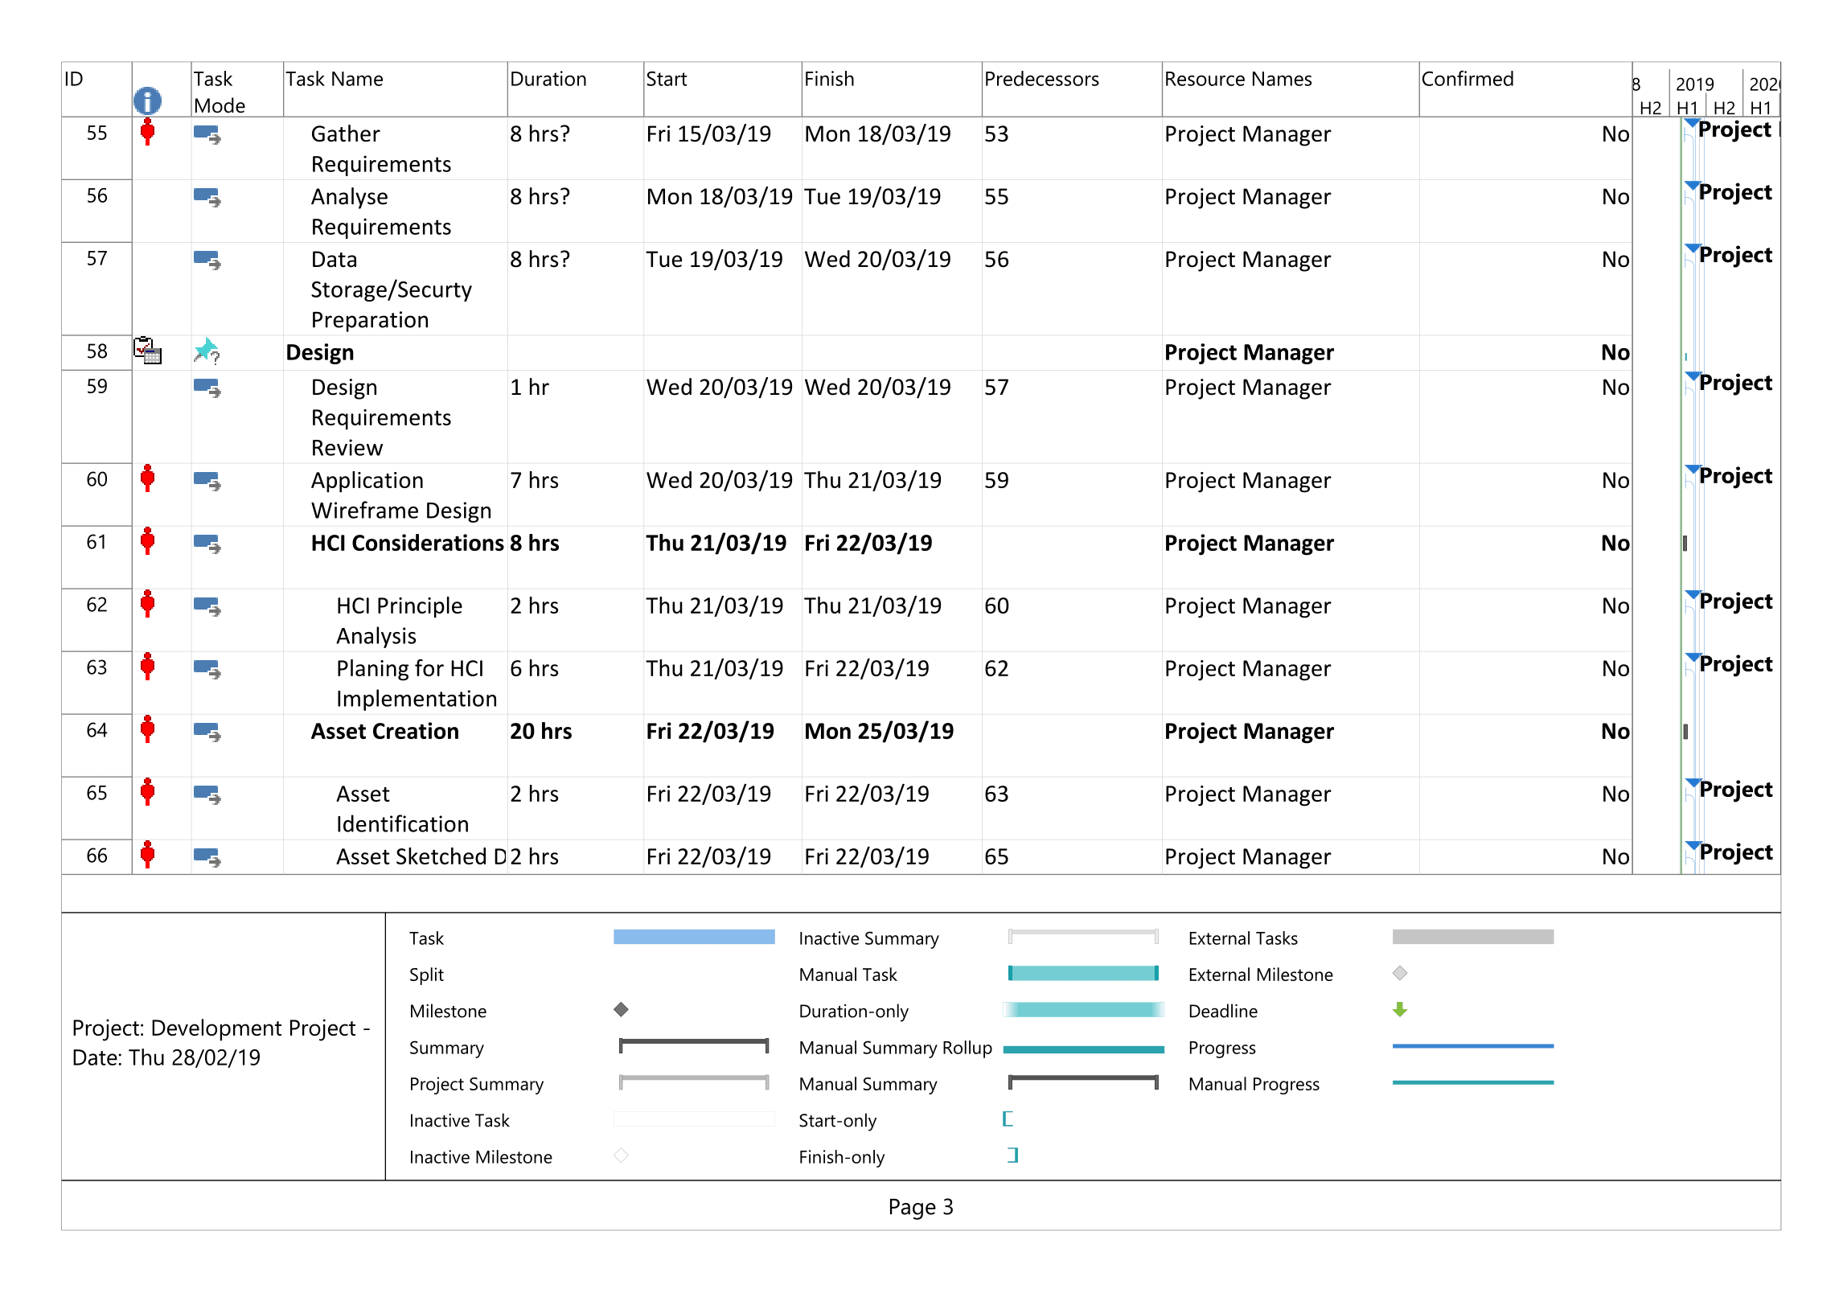

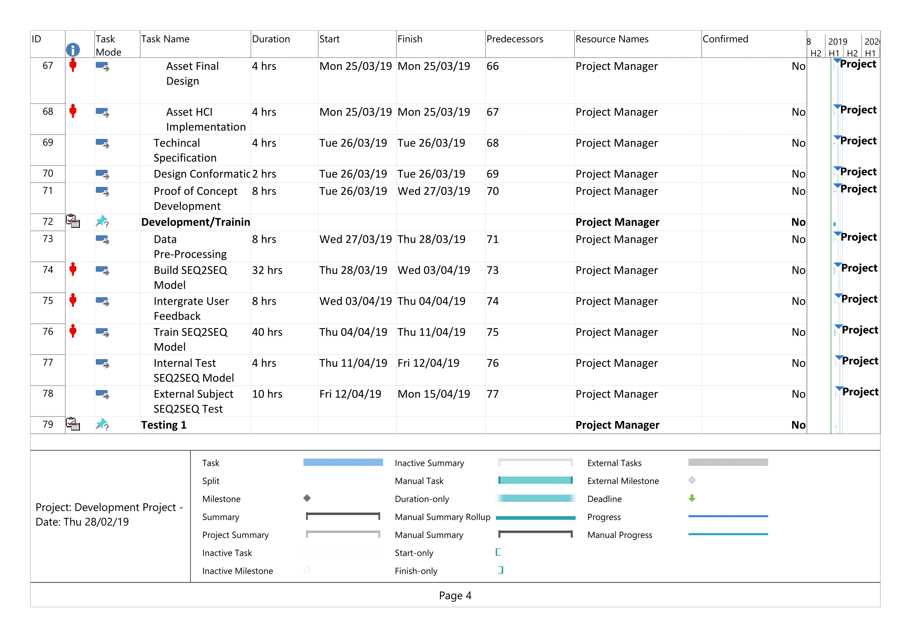

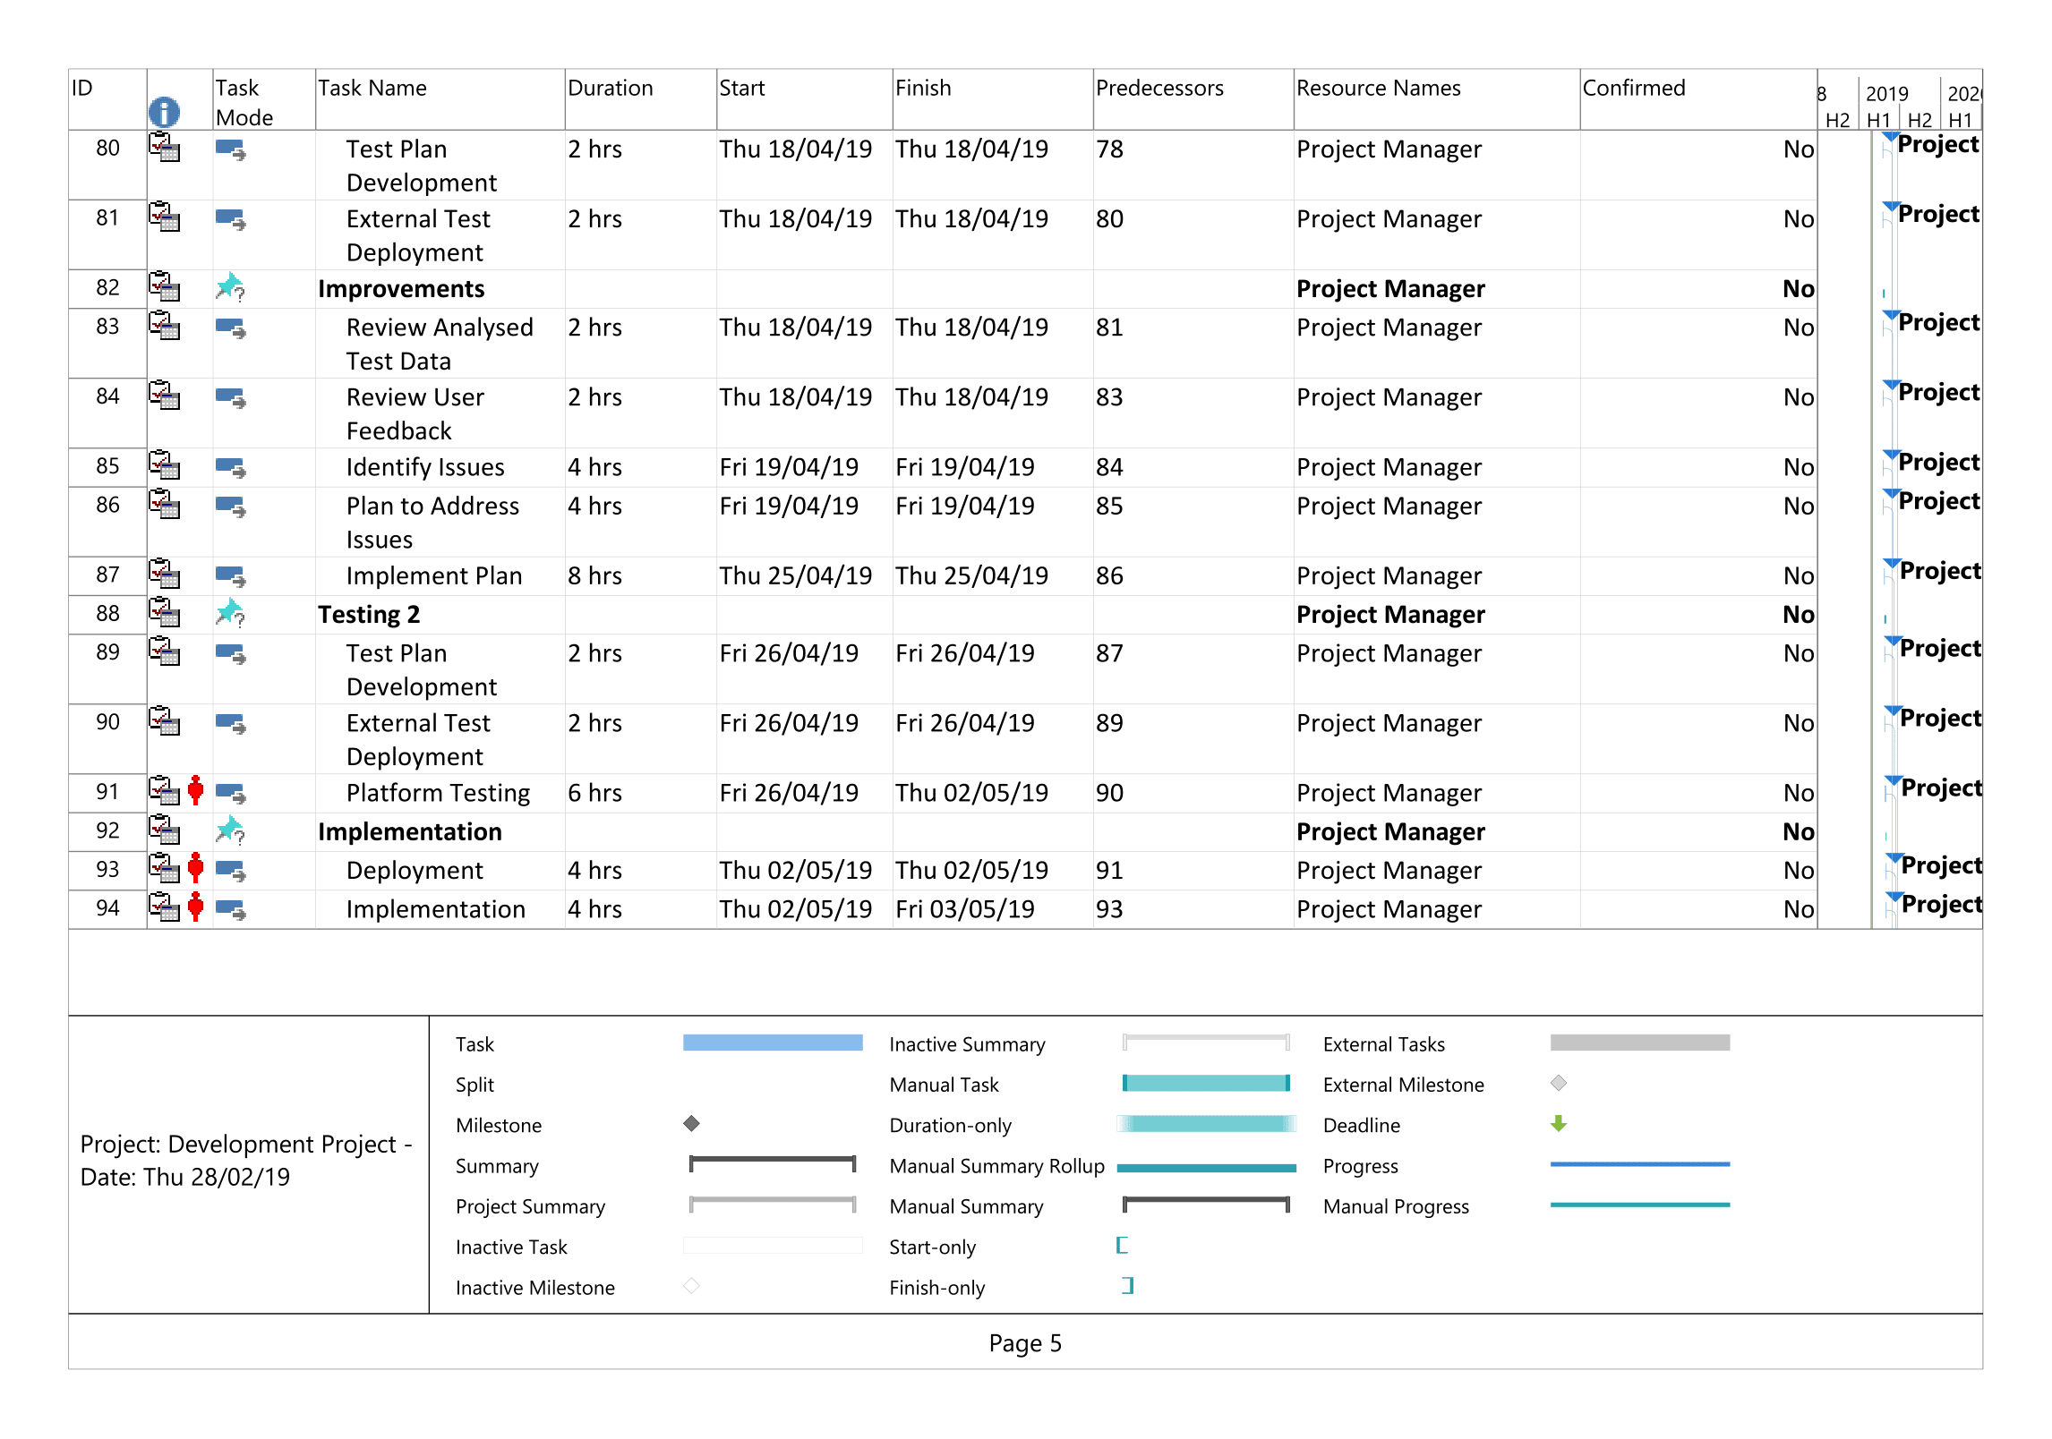

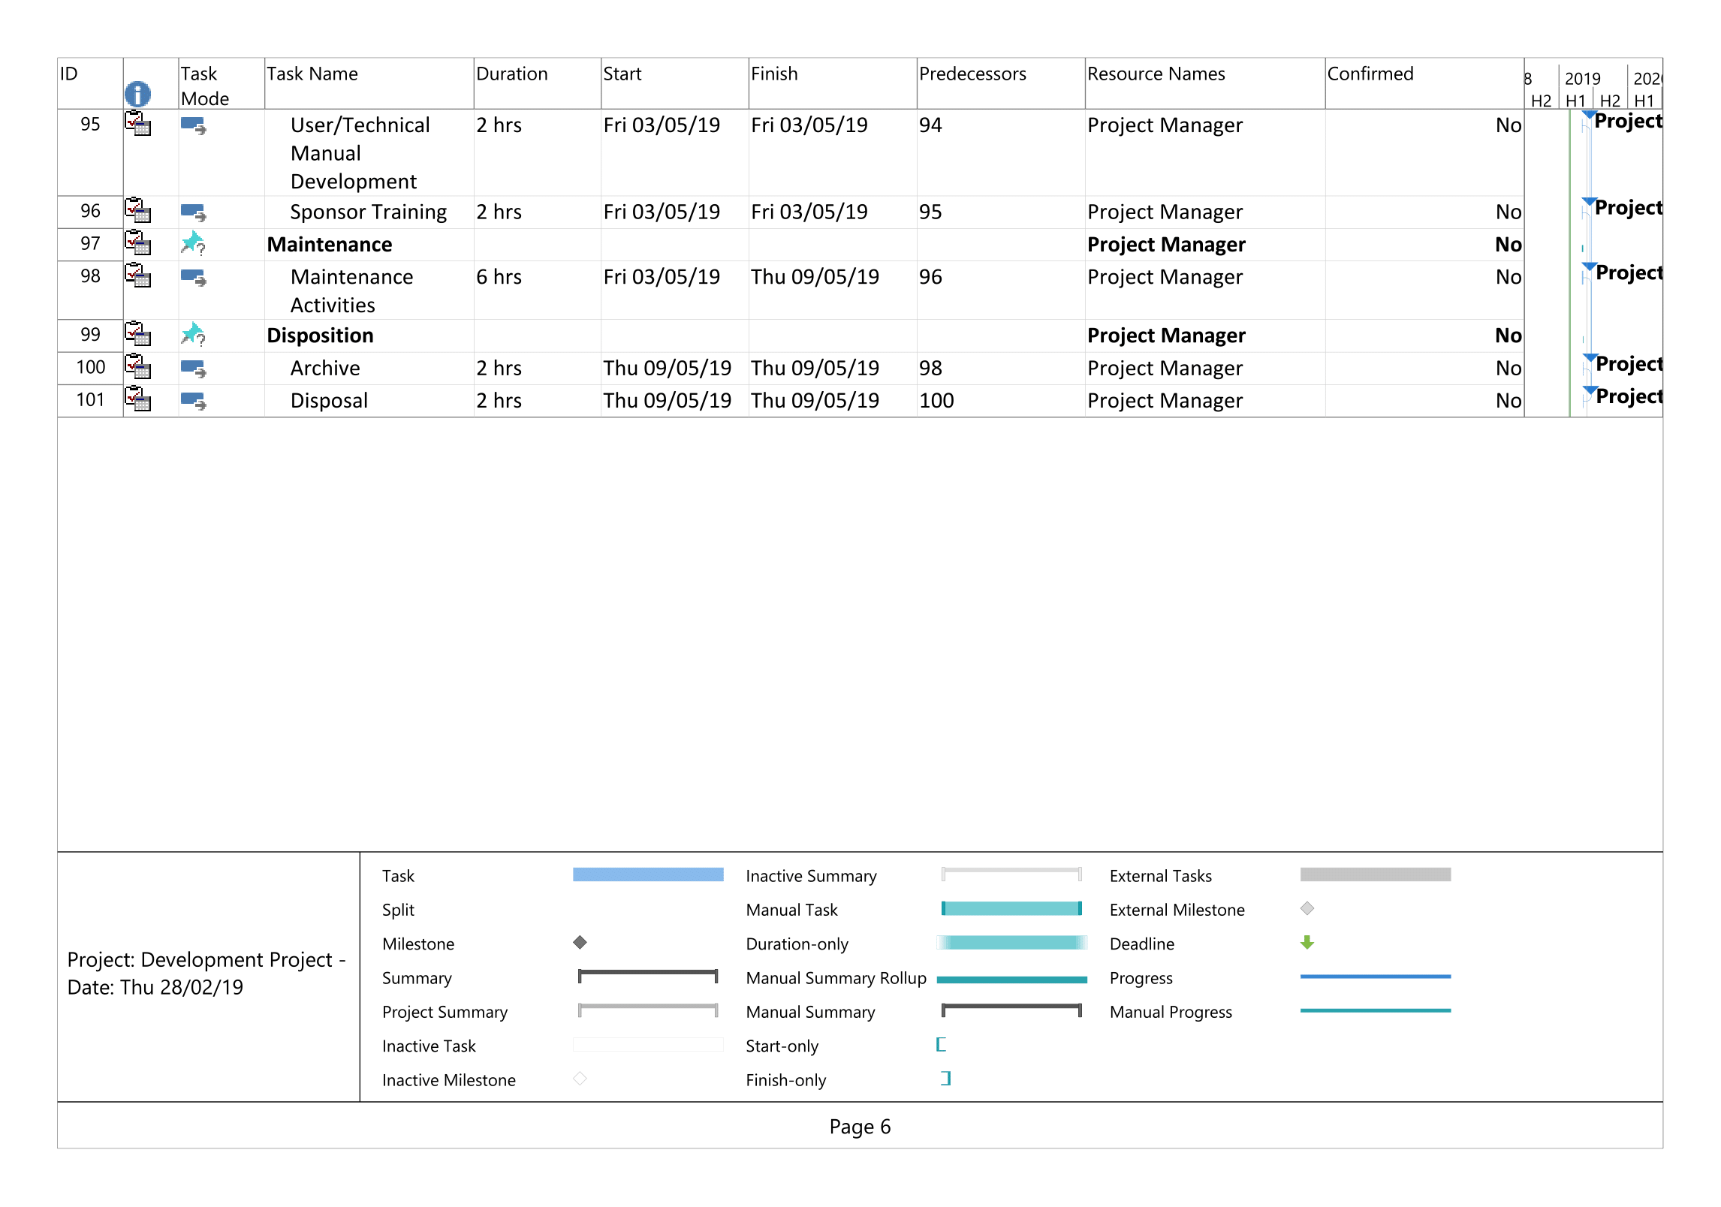

## Appendices C – Change Request Form

The proposed project change request form can be found below.

